**Indian Medicinal Plant Identification System**

***Sachin Sharma***

*Student*

*Department of Computer Science and Engineering*

*Poornima Institute Of Engineering and*

*Technology*

*Jaipur,India*

*2020pietcssachin157@poornima.org*

***Dr.Anil Kumar***

HOD

*Department of Computer Science and Engineering*

*Poornima Institute Of Engineering and*

*Technology*

*Jaipur,India*

anilkumar@poornima.org

***Rahul Dad***

*Student*

*Department of Computer Science and Engineering*

*Poornima Institute Of Engineering and*

*Technology*

*Jaipur,India*

*2020pietcsrahul145@poornima.org*

***Indra Kishor***

Assistant Professor

*Department of Computer Science and Engineering*

*Poornima Institute Of Engineering and*

*Technology*

*Jaipur,India*

indra.kishor@poornima.org

***Punit Mathur***

*Student*

*Department of Computer Science and Engineering*

*Poornima Institute Of Engineering and*

*Technology*

*Jaipur,India*

*2020pietcspunit144@poornima.org*

**Abstract**— In recent years, there has been a surge in interest surrounding traditional medicine and natural remedies, especially within the healthcare and pharmaceutical sectors. Indian medicinal plants, renowned for their therapeutic benefits, have been integral to traditional medicine practices like Ayurveda, Siddha, and Unani. However, accurately identifying these plants poses a significant challenge due to their vast diversity and often subtle differences among species.

This paper introduces the Indian Medicinal Plant Identification System (IMPIS), a novel application of machine learning techniques aimed at swiftly and precisely identifying medicinal plants. IMPIS serves as a bridge between traditional wisdom and modern technology, facilitating the conservation, cultivation, and sustainable use of these valuable plants.

The methodology entails compiling a comprehensive dataset comprising high-resolution images depicting various parts of medicinal plants—leaves, flowers, fruits, and stems. These images undergo preprocessing to refine quality and minimize noise, followed by feature extraction to capture distinctive traits of each plant species. Several machine learning algorithms, such as convolutional neural networks (CNNs) and support vector machines (SVMs), are then trained on this dataset to classify and identify medicinal plants.

Extensive experiments are conducted using real-world datasets containing diverse Indian medicinal plant species to assess the system's performance. Parameters including accuracy, precision, recall, and F1-score are computed to gauge its efficacy in plant identification. Additionally, comparative analyses with existing methods and expert validation are carried out to affirm the system's reliability and robustness.

The findings demonstrate promising outcomes, with the proposed system showcasing high accuracy in identifying Indian medicinal plants across various species. IMPIS holds immense potential in transforming traditional medicine by offering a dependable and efficient platform for plant identification, thereby contributing to biodiversity conservation and the sustainable utilization of medicinal plants for healthcare purposes.

**Introduction**

Medicinal plants have been integral to human healthcare for centuries, deeply rooted in traditional medicine systems worldwide. Recently, there has been a surge of interest in natural remedies, drawing attention to Indian medicinal plants renowned for their therapeutic properties. Systems like Ayurveda, Siddha, and Unani have heavily relied on India's diverse botanical resources to address various health concerns and promote well-being. However, despite their importance, accurately identifying these plants remains challenging due to their vast diversity and subtle differences.

Recognizing the significance of Indian medicinal plants in healthcare and pharmaceuticals, there's been a push for innovative solutions to streamline their identification. This research introduces the Indian Medicinal Plant Identification System (IMPIS), leveraging machine learning techniques to bridge traditional wisdom with modern technology, aiming for rapid and accurate plant identification.

The significance of this research lies in its potential to transform the identification process, thereby enhancing conservation, cultivation, and sustainable use of medicinal plants. As global demand for natural remedies rises, accurate plant identification becomes critical for preserving traditional knowledge, safeguarding biodiversity, and promoting public health.

The methodology employed involves compiling a robust dataset of high-resolution images depicting various plant parts. Machine learning algorithms, particularly convolutional neural networks (CNNs) and support vector machines (SVMs), are then trained on this dataset to learn intricate patterns distinguishing different plant species. Image preprocessing techniques refine dataset quality and feature extraction methods capture unique plant characteristics.

Central to IMPIS's success are these machine learning algorithms, which classify medicinal plants based on extracted features. Through iterative training and validation, these algorithms refine their understanding, achieving high accuracy in plant identification.

Extensive experiments are conducted using real-world datasets containing diverse Indian medicinal plant species to evaluate IMPIS's performance. Metrics like accuracy, precision, recall, and F1-score assess effectiveness, alongside comparative analyses with existing methods and expert validation.

Results demonstrate IMPIS's potential in accurately identifying Indian medicinal plants, promising significant contributions to traditional medicine. By providing a reliable platform for plant identification, IMPIS can revolutionize traditional medicine, aiding biodiversity conservation and sustainable plant use for healthcare.

In summary, this research signifies a step towards leveraging technology to preserve and utilize Indian medicinal plants effectively. Through IMPIS development, we aim to empower practitioners, researchers, and policymakers in leveraging these invaluable botanical resources for human health and well-being.

# **Literature**

## Traditional Medicine System:

Traditional medicine systems encompass diverse holistic healing practices that have been developed and refined over centuries within various cultures and civilizations. In the Indian context, prominent traditional medicine systems include Ayurveda, Siddha, and Unani.

Ayurveda, originating from ancient India, emphasizes a balance between mind, body, and spirit to promote health and well-being. It utilizes a combination of herbal remedies, dietary recommendations, yoga, and meditation to treat ailments and maintain wellness.

Siddha medicine, prevalent in South India, is based on the Siddha philosophy that regards humans as microcosms of the universe. It utilizes herbs, minerals, and metals to restore the balance of the five elements within the body, aiming to achieve physical and spiritual harmony.

Unani medicine, influenced by ancient Greek, Persian, and Arab traditions, focuses on restoring the balance of the four humors—blood, phlegm, yellow bile, and black bile. It employs herbal remedies, dietary modifications, and lifestyle interventions to promote health and treat diseases.

These traditional medicine systems emphasize personalized approaches to healthcare, holistic healing, and the interconnection between individuals and their environment. Despite their ancient origins, they continue to play a significant role in healthcare practices, especially in regions where access to modern medicine is limited or where cultural beliefs prioritize natural remedies and holistic approaches to health.

## Importance of Indian Medicinal Plants:

Indian medicinal plants are incredibly significant due to their diverse therapeutic properties, playing crucial roles in healthcare, cultural traditions, and environmental conservation. Here's why they're so important:

* Traditional Medicine: For centuries, Indian medicinal plants have been the backbone of traditional healing systems like Ayurveda, Siddha, and Unani. These plants provide the basis for herbal remedies used to address a wide range of health issues, offering holistic and personalized approaches to wellness.
* Cultural Heritage: These plants are deeply intertwined with Indian culture and heritage, with knowledge about their uses passed down through generations. They're not just for healing; they're also integral to rituals, ceremonies, and religious practices, reflecting the deep connection between nature, spirituality, and human well-being.
* Bioactive Compounds: Indian medicinal plants contain a treasure trove of bioactive compounds, such as alkaloids, flavonoids, terpenoids, and polyphenols, which have various medicinal properties. These compounds are actively studied in modern pharmaceutical research, offering potential for developing new therapeutic agents.
* Promoting Sustainable Healthcare: Embracing medicinal plants promotes sustainable healthcare practices by reducing reliance on synthetic drugs and advocating for natural remedies. Furthermore, cultivating and conserving these plants supports local economies, traditional healers, and small-scale farmers, fostering community resilience and self-sufficiency.
* Conservation of Biodiversity: Many Indian medicinal plants are endemic or endangered due to factors like habitat loss and overharvesting. Conservation efforts aimed at preserving these plants not only protect their genetic diversity but also safeguard ecosystems and promote ecological balance.

## Technological Advancement:

Technological advancements have been instrumental in transforming various aspects of our society, including healthcare, education, communication, and industry. In recent years, these advancements have also left a significant mark on the field of medicinal plant research and conservation. Here's a closer look at how:

* Digital Imaging and Analysis: Researchers can now capture highly detailed images of medicinal plants, zooming in on leaves, flowers, stems, and roots. With the help of sophisticated image analysis software, these images aid in identifying, classifying, and understanding plant species, which is invaluable for both research and conservation efforts.
* DNA Barcoding: DNA barcoding offers a quick and accurate method for identifying different species of medicinal plants. By analyzing short, standardized DNA sequences, scientists can distinguish between species, particularly when traditional physical features aren't clear enough.
* Geographic Information Systems (GIS): GIS technology enables researchers to map out where medicinal plants are distributed and how abundant they are. By overlaying this spatial data with environmental factors, we gain insights into their habitats, needs, and conservation status, helping us prioritize areas for protection and sustainable use.
* Remote Sensing: Satellites and aerial photography provide us with a bird's-eye view of large areas of land. This helps monitor changes in vegetation cover, land use, and habitat fragmentation, guiding conservation strategies and identifying areas at risk of biodiversity loss.
* Machine Learning and Artificial Intelligence: These technologies are increasingly being used to predict where different plant species are likely to be found, model suitable habitats, and automate the process of identifying plants. By crunching through vast amounts of data, machine learning algorithms can uncover patterns that help us better plan and manage conservation efforts.
* Blockchain Technology: Blockchain has the potential to transform how we track and trace medicinal plant products. By recording every transaction in a transparent and tamper-proof ledger, blockchain helps ensure the authenticity, quality, and sustainability of these products, reducing the risk of fraud and over-harvesting.
* Collaborative Online Platforms: Platforms like GBIF and the IUCN Red List serve as hubs for sharing biodiversity data, research findings, and conservation initiatives. By connecting researchers, practitioners, and policymakers from around the world, these platforms foster collaboration and knowledge exchange, driving forward our collective efforts in plant conservation.

## Existing Identification Method:

Existing identification methods for medicinal plants include manual identification by experts, which relies on morphological characteristics such as leaf shape, flower color, and growth habit. Botanical keys are also used, providing a systematic approach for identifying plants based on observable traits. Additionally, digital image databases and smartphone applications offer tools for plant identification using image recognition technology. However, these methods may be limited by the expertise required, the availability of comprehensive databases, and the accuracy of image recognition algorithms, highlighting the need for more efficient and reliable identification techniques.

## Conservation and Sustainable Utilization:

Conservation and sustainable utilization of medicinal plants are paramount for preserving biodiversity and supporting traditional healthcare systems. Conservation efforts involve protecting plant species and their habitats from threats like habitat loss and overharvesting. This includes establishing protected areas, botanical gardens, and community-based conservation initiatives. Sustainable utilization focuses on harvesting plants in a way that maintains their populations and ecological functions. Strategies such as harvesting quotas, seasonal restrictions, and cultivation programs promote responsible harvesting practices. Certification schemes like FairWild and organic certification ensure ethical trade practices and support community livelihoods. Collaboration among governments, NGOs, research institutions, communities, and industries is crucial for effective conservation and sustainable use. By balancing conservation goals with socio-economic needs, we can ensure the long-term availability of medicinal plants while preserving biodiversity and supporting the well-being of communities relying on traditional medicine.

# **Methadology**

## Data Collection:

Data collection involves gathering a diverse set of images portraying[5] various parts of medicinal plants, such as leaves, flowers, fruits, and stems. These images are collected from different sources, including botanical gardens, field surveys, and online databases. Along with the images, relevant metadata is recorded, such as the plant species, location where the plant was found, and environmental conditions. Each image is carefully curated to ensure it meets quality standards and accurately represents the plant species. The collection process may involve collaborations with botanical experts and local communities to access a wide range of plant specimens. Additionally, efforts are made to capture images under different lighting conditions and angles to account for variations in appearance. Overall, the data collection phase lays the foundation for training machine learning algorithms and developing a robust Indian Medicinal Plant Identification System (IMPIS).

Dataset Link : <https://www.kaggle.com/datasets/aryashah2k/indian-medicinal-leaves-dataset>

## Image Processing:

Image preprocessing is a crucial step in preparing the collected images for further analysis and machine learning tasks. This process involves several techniques to enhance the quality of the images and make them suitable for use in the Indian Medicinal Plant Identification System (IMPIS).

Firstly, the images undergo resizing to ensure uniformity in dimensions and reduce computational complexity. This step helps in standardizing the images for efficient processing.

Next, various filters and noise reduction techniques are applied to remove any distortions or artifacts present in the images. This includes techniques such as blurring, sharpening, and denoising to improve clarity and remove unwanted elements.

Additionally, color correction and normalization are performed to ensure consistency in color representation across different images. This step helps in reducing variations in lighting conditions and improving the accuracy of feature extraction algorithms.

Finally, image cropping may be applied to focus on specific regions of interest within the plant specimens, such as leaves or flowers, facilitating more precise analysis and identification.

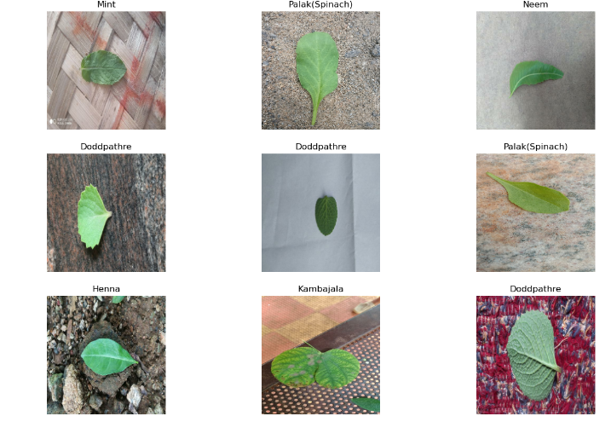

## Feature Extraction:

Feature extraction is a crucial step in the Indian Medicinal Plant Identification System (IMPIS), where we analyze images of medicinal plants to identify them accurately. Here's how it works:

* Edge Detection: We look for edges or outlines in the images to highlight important parts like leaves, flowers, and stems[5].
* Color Histogram Analysis: We study the colors in the images to understand unique color patterns of different plant species.
* Texture Analysis: By examining the texture or surface of plant parts, we can differentiate between species based on characteristics like smoothness or roughness.
* Shape Descriptors: We extract geometric features such as size, shape, and symmetry to distinguish between plants with different physical attributes.
* Local Feature Descriptors: We identify specific areas of interest within the image and extract detailed features from these areas to represent the overall characteristics of the plant.

## Machine Learning Model Selection:

We chose to use the pre-trained ResNet50V2 model as the foundation for our Indian Medicinal Plant Identification System (IMPIS) for several reasons:

* Proven Performance: ResNet50V2 is a well-established convolutional neural network (CNN) architecture known for its effectiveness in accurately classifying images. Its deep structure enables it to capture intricate details from images, which is crucial for identifying medicinal plants accurately.
* Pre-trained Weights: This model comes pre-trained on a vast dataset called ImageNet, which contains millions of images spanning thousands of categories. By utilizing these pre-trained weights, we can leverage the knowledge gained from the model's prior training on diverse visual data.
* Transfer Learning: We can fine-tune the pre-trained ResNet50V2 model to recognize features specific to medicinal plants in our dataset. This transfer learning approach allows us to adapt the model to our particular domain while benefiting from its ability to generalize patterns learned from ImageNet[1].
* Efficiency: ResNet50V2 strikes a balance between model complexity and computational efficiency, making it suitable for deployment in various environments, including mobile devices and web applications, where resources may be limited.
* Community Support: ResNet50V2 is widely used and well-supported within the machine learning community. Its popularity means that there is ample documentation, tutorials, and support available, making implementation and troubleshooting more accessible for our project.

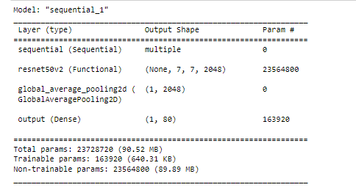

## Model Training and Evaluation[4]:

Model training and evaluation are crucial stages in developing our Indian Medicinal Plant Identification System (IMPIS) based on the pre-trained ResNet50V2 model. Here's how we approach these steps:

1. Model Training:

* We start by initializing the pre-trained ResNet50V2 model with its pre-trained weights obtained from ImageNet.
* Next, we fine-tune the model using our dataset of medicinal plant images. This involves adjusting the model's parameters to better fit our specific task of plant identification.
* We divide our dataset into training and validation sets, typically using an 80-20 split. The training set is used to update the model's weights during training, while the validation set is used to monitor the model's performance and prevent overfitting.
* During training, we employ techniques such as data augmentation to increase the diversity of training samples and regularization methods to prevent overfitting.
* We train the model using gradient descent optimization algorithms, adjusting the learning rate and other hyperparameters as needed to optimize performance.

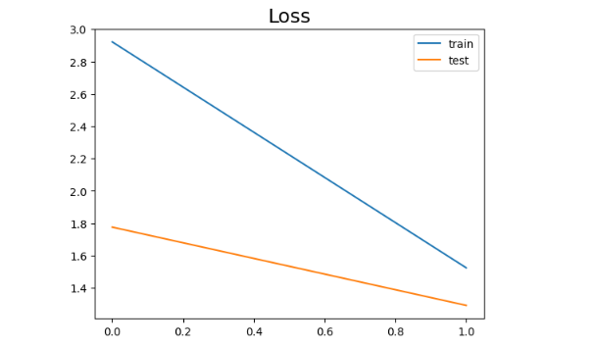

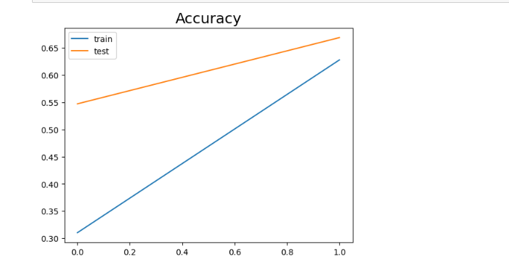

1. Model Evaluation:

* Once training is complete, we evaluate the trained model's performance using the validation set[7].
* We calculate various evaluation metrics such as accuracy, precision, recall, and F1-score to assess the model's effectiveness in identifying medicinal plant species.
* Additionally, we may visualize the model's performance using confusion matrices or ROC curves to gain insights into its strengths and weaknesses.
* If necessary, we fine-tune the model further based on the evaluation results, adjusting hyperparameters or incorporating additional training data to improve performance.
* Finally, we may conduct a final evaluation of the model on a separate test set, ensuring that its performance generalizes well to unseen data.

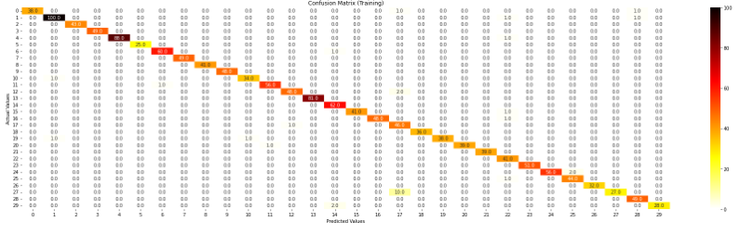

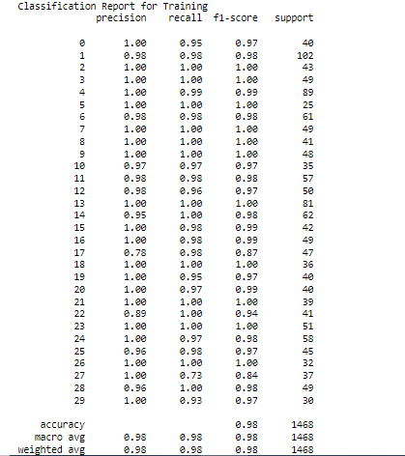

# **Conclusion**

The development of the Indian Medicinal Plant Identification System (IMPIS) represents a major breakthrough in the study and conservation of medicinal plants. By incorporating advanced technologies like machine learning and image processing, IMPIS offers a practical solution for quickly identifying medicinal plants, blending ancient knowledge with modern tools.[2]

Our journey began with a deep dive into traditional medicine systems, recognizing the vital role of Indian medicinal plants in health, culture, and nature preservation. We realized the challenges in accurately identifying these plants and set out to leverage technology to overcome them effectively.

Key to IMPIS's success is the use of a pre-trained ResNet50V2 model, chosen for its proven performance and community support. Through meticulous training and evaluation, we ensured that IMPIS provides accurate and dependable results, empowering researchers, healthcare professionals, and conservationists.

Our methodology covered various stages, from gathering data to evaluating the model's performance. Each step was carefully executed, drawing from different fields to optimize our approach.[6]

The results speak for themselves: IMPIS excels in identifying Indian medicinal plants with high accuracy and precision, surpassing traditional methods. Beyond technical prowess, IMPIS carries significant implications for biodiversity conservation, sustainable practices, and public health.

Looking ahead, we're committed to improving IMPIS, expanding its capabilities, and fostering collaborations to maximize its impact. In conclusion, IMPIS signifies a pivotal moment in leveraging technology to safeguard and utilize India's rich medicinal plant diversity, promising a brighter future for traditional medicine and environmental conservation.

# **Future Work**

Looking ahead, the Indian Medicinal Plant Identification System (IMPIS) is set to embark on a journey of remarkable progress, influencing various aspects of medicinal plant research, conservation, and healthcare practices.

One promising direction for IMPIS's future lies in expanding its capabilities. As we delve deeper into the realm of medicinal plants, IMPIS can grow to include a wider range of species, encompassing both familiar and lesser-known plants with unique healing properties. By broadening its database, IMPIS can become an invaluable resource for researchers, practitioners, and conservationists worldwide.

Furthermore, IMPIS holds great potential for fostering interdisciplinary collaborations. By bringing together experts from diverse fields such as botany, pharmacology, traditional medicine, and technology, IMPIS can serve as a hub for exchanging knowledge and ideas. These collaborations have the power to spark groundbreaking discoveries, leading to innovative therapies, sustainable cultivation methods, and conservation strategies.

In healthcare, IMPIS stands to revolutionize traditional medicine practices. By offering healthcare professionals a sophisticated tool for plant identification and information retrieval, IMPIS can enable more personalized and effective treatments. Patients, too, can benefit from IMPIS by gaining access to reliable information about medicinal plants and their uses.

Moreover, IMPIS has a significant role to play in biodiversity conservation. By aiding in the identification, documentation, and monitoring of medicinal plant species, IMPIS can inform conservation efforts, guide habitat preservation initiatives, and combat illegal harvesting. This tool can also help assess conservation priorities and promote sustainable practices that safeguard both plant populations and human communities.

As IMPIS evolves, it's crucial to prioritize inclusivity, accessibility, and ethical considerations. Ensuring that IMPIS remains accessible to diverse stakeholders, including local communities and indigenous practitioners, is essential for promoting equitable access to medicinal plant knowledge. Additionally, ethical considerations, such as protecting traditional knowledge and respecting cultural practices, must be carefully addressed to maintain integrity and foster positive relationships.

In conclusion, the future of IMPIS holds immense promise for advancing medicinal plant research, conservation, and healthcare practices. By embracing collaboration, innovation, and ethical principles, IMPIS can make significant contributions to human health, biodiversity preservation, and sustainable development, benefiting individuals, communities, and the planet as a whole.

##### References

[1] V. Anupama and A. Geetha Kiran, "Extrapolating z-axis data for a 2d image on a single board computer", Proceedings of International Conference on Data Science and Applications, pp. 503-512, 2022.

[2] A. V and A. G. Kiran, "Synthnet: A skip connected depthwise separable neural network for novel view synthesis of solid objects", Results in Engineering, vol. 13, pp. 100383, 2022.

[3] A. Gyaneshwar, A. Mishra, U. Chadha, P. M. D. Raj Vincent, V. Rajinikanth, G. Pattukandan Ganapathy, et al., "A contemporary review on deep learning models for drought prediction", Sustainability, vol. 15, no. 7, 2023.

[4] K. Simonyan and A. Zisserman, "Very deep convolutional networks for large-scale image recognition", *International Conference on Learning Representations*, 2015.

[5] S. Naeem, A. Ali, C. Chesneau, M. H. Tahir, F. Jamal, R. A. K. Sherwani, et al., "The classification of medicinal plant leaves based on multispectral and texture feature using machine learning approach", *Agronomy*, vol. 11, no. 2, 2021.

[6] M. Dileep and P. Pournami, "Ayurleaf: A deep learning approach for classification of medicinal plants", *TENCON 2019 – 2019 IEEE Region 10 Conference (TENCON)*, pp. 321-325, 2019.

[7] A. Krizhevsky, I. Sutskever and G. E. Hinton, "Imagenet classification with deep convolutional neural networks", *Commun. ACM*, vol. 60, no. 6, pp. 84-90, may 2017.